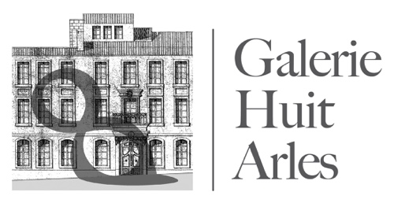

8 rue de la Calade
13200 ARLES
Portable : +33 (0) 6 82 04 39 60 julia@galeriehuitarles.com
www.galeriehuitarles.com

Artist in Residency Online Application Form
Can be submitted in French or English
Date :
Name :
Address :
Phone (mobile and/or landline):
Email address:
Website address, if available:
Male/ Female
Date of birth:
Nationality:
Languages:
Current occupation:
What is your specific discipline or field of study:
Please attach an outline to explain the rationale and goals of your project and what you ultimately hope to accomplish during the Galerie Huit residency:

Please indicate your preferred dates and length of stay:
How did you hear about our residency?
How do you plan to fund your stay?
Does your project have any special needs or requirements, beyond what you are bringing with you?

Required attachments:
Please send the requested attachments along with your online application:
- One reference from an individual familiar with you and your work, including their contact details.
- Resume/Curriculum Vitae
- Work samples or similar, if possible, reflecting the type of project you are pursuing.

Please send completed form and attachments to: julia@galeriehuitarles.com.

